Battery installation method.
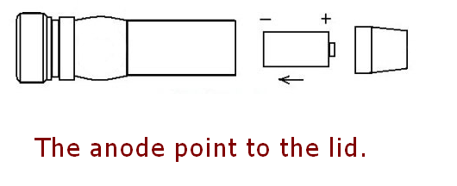
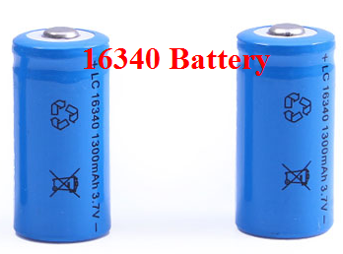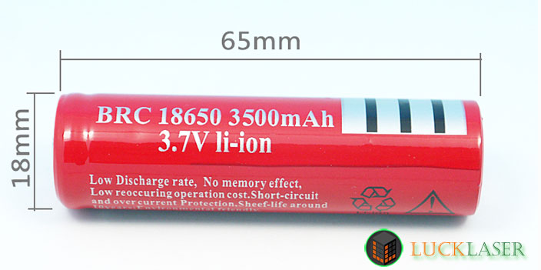

18650 battery OR 16340 battery (Not Include)
WARNING
1. Never look directly into the laser beam.
2. Never point a laser beam at a person.
3. Do not aim the laser at reflective surfaces.
4. Do not allow children to use laser pointers unless under the supervision of an adult.

Battery installation method.
18650 battery OR 16340 battery (Not Include)
WARNING
1. Never look directly into the laser beam.
2. Never point a laser beam at a person.
3. Do not aim the laser at reflective surfaces.
4. Do not allow children to use laser pointers unless under the supervision of an adult.

